

IO1: Psychographic Profiling Tools

Guidelines to using a psychographic tool in order to match senior volunteers to migrants

**Recruitment**

Partners in the Silver Service project have already indicated how they will recruit senior volunteers and migrants when the implementation phase is live. Depending on the nature of the organisation, some will recruit via their own programmes of work and some through affiliated associations. It is important that each partner disseminates widely the nature of the project in order to reach the widest group of volunteers and migrants possible.

**Organisation of meetings with potential participants**

Once senior volunteers and migrants are recruited, each partner should meet each group separately. Materials should be prepared in advance and participants should have access to computers etc. It would be welcoming to have some drinks and snacks available. The session could be organised as follows:

* Presentation of the main aims of the Silver Service project
* Signatures to authorise the use of photos/videos during the project
* Presentation of the profiling tools
* Gathering the results
* Feedback

**Using the psychographic tools**

Psychographics is a term borrowed from the world of marketing and consumer studies. Until very recently, consumer profiling was based around demographics but a psychographic profile can contain information around a person’s interests, hobbies, emotional triggers, and lifestyle choices, among other data. This could provide insight into *why* someone might buy a specific product, support a given cause, vote a certain way, and much more.

In the Silver Service project, we will use a psychographic tool (questionnaire) to find out about the senior volunteer and the migrant to help to match in a best way the profiles of migrants with profiles of senior volunteers.

The tool can be used on line or in a face to face situation. The information from the profile can also be used to create ice-breakers and activities for the first meetings of possible ‘matches’.

‘Soft matching’ is a concept from Volunteering Matters’ Grand mentors programme which matches older volunteers with plenty of professional and life experience to young people leaving the care system who need additional support to keep them focused on education, employment and training.

Instead of going straight to a ‘match’, the volunteer manager organises a fun activity for a group of senior volunteers and young people. Within the group are contained potential matches. During the activity the two groups get to know each other and reflect on whether their relationship could work or not and whether they are compatible. This is an excellent way of practically organising the matching process. More details here (*link to real Grand mentor’s example)*

You might want to ask your volunteers and migrants to take a short personality test to back up your questionnaire material. An optional activity that can be fun and it’s free provided by ©2011-2020 NERIS Analytics Limited. <https://www.16personalities.com/free-personality-test>

*There will be a section at the end of the questionnaire where participants can share the broad details of the results of their test, if they choose, bearing data protection rules in mind.

When the profile questionnaires have been completed by the senior volunteers and the migrants, the volunteer manager should analyse the questionnaires and turn them into a text profile for each person. Here is an example of a full time volunteer profile *(link to Jessica’s profile).* This should make the eventual matching process easier and eventually more successful.

A useful visualisation of the potential matches could be through a spider diagram. Here are the instruction on how to use this with participants *(Link to spider diagram)*

**Questionnaire**

<https://docs.google.com/forms/d/e/1FAIpQLSfPGs4px_-TCqfmufFlWq1ZNAia6hxk4L0CLv1UIPFhCm-TqQ/viewform>

|  |  |
| --- | --- |
| **Personal Information** | |
| Name: |  |
| Date of birth: |  |
| Nationality: |  |
| Address: |  |
| Academic qualifications: |  |
| Profession (active or retired): |  |
| Current status (student, retired, employee, unemployed, other): |  |
| Driving license: |  |
| Availability: (daily, weekly, weekends only, weekdays only, fortnightly, monthly): |  |
| Schedule (morning, afternoon, evening): |  |
| Previous and current voluntary activity: |  |
| Language(s) spoken: |  |
| **Areas of interest (tick any that apply and provide as much detail as possible)** | |
| Science |  |
| New technologies |  |
| Arts and crafts |  |
| Art |  |
| Music (please state what genre(s)) |  |
| Do you play a musical instrument? If so, which one(s) |  |
| Dance (please state what genre(s) |  |
| Do you enjoy watching or practising? |  |
| Reading (what are your preferred topics/fiction/non-fiction) |  |
| Sport (which? Do you play sport(s) or prefer to watch/) |  |
| Cookery |  |
| Nature/environmental issues/animals |  |
| Gardening |  |
| History |  |
| Local history |  |
| **Other skills and interests (please tick any that apply and an approximate level)**  Do you have any of the following skills? | |
| Computing (coding, use of applications such as Word, Excel etc) | Yes  Low Level  Medium Level  High Level |
| Social media | Yes  Low Level  Medium Level  High Level |
| Website building | Yes  Low Level  Medium Level  High Level |
| Teaching (either professionally or as a volunteer) | Yes  Low Level  Medium Level  High Level |
| Design | Yes  Low Level  Medium Level  High Level |
| Financial | Yes  Low Level  Medium Level  High Level |
| Legal | Yes  Low Level  Medium Level  High Level |
| Any other | Yes  Low Level  Medium Level  High Level |
| **Volunteering with Silver Service** | |
| What do you want to gain from this volunteering experience? |  |
| Do you consider that you need any training? |  |
| Do you have any health conditions or disability that you wish to be taken into consideration? |  |
| Do you have any religious or political beliefs that you wish to be taken into consideration? |  |
| Would you prefer to be matched with a man or a woman? |  |
| What kind of personality are you? **Only if you wish**, please broadly share the results of the personality test, if you took it[1] |  |
| Are you prepared to have a [2]Police check? |  |

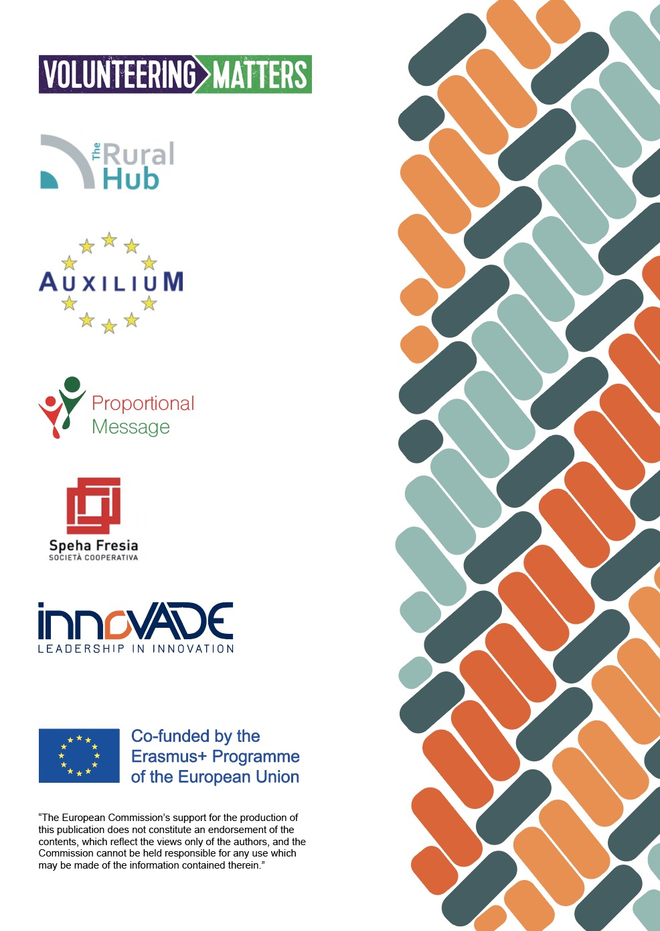

1. *Optional activity. Is a free personality test provided by ©2011-2020 NERIS Analytics Limited
2. *this would only apply to countries where this is mandatory